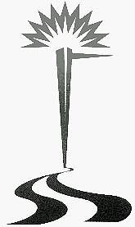MID-WEST ELECTRIC CONSUMERS ASSOCIATION, INC.
67th Annual Meeting
OFFICIAL DELEGATE FORM

PLEASE COMPLETE ALL BLANKS

==============================================================================
ORGANIZATION

________________________________________________________________________________________
STREET CITY STATE ZIP

We are a voting member of Mid-West Electric Consumers Association, Inc., and hereby appoint

Name: ________________________________________________________________________________

whose home address is___________________________________________________________________
STREET CITY STATE ZIP

*Delegate Email:

to officially represent us and vote on all matters of business that may come before the members of Mid-West Electric Consumers Association, Inc., at its 66th Annual Meeting of members in Denver, Colorado, December 10-12, 2024.

Name of appointed alternate delegate:

Name:________________________________________________________________________________

______________________________________________________________________________________
STREET CITY STATE ZIP

*Alternate Email:

SIGNED:_______________________________________

Title: _______________________________________

Please mail to: Mid-West Electric Consumers Association, Inc.
P.O. Box 7279
Denver, Colorado 80207
Ph: 303-463-4979 or email meca@meconsumers.com
*Email will be used only for Annual Meeting updates.

